Mehlville 1st Ever International Club FESTIVAL
Saturday, April 20th, 2013 from 1-5pm
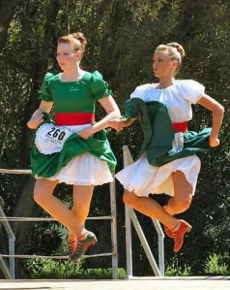
Bernard Middle School, 1054 Forder Road
****FREE TO ENTER***
Scheduled LIVE Entertainment:
Bosnian Dancers

German Dancers
Scottish Bagpipers
Irish Dancers

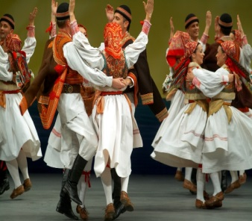
Orchestra Music from Around the World
Croatian Dancers

Food from around the world
USA SPAIN BOSNIA PERU MEXICO TURKEY GERMANY INDIA SOUTH KOREA
WINTER HOLIDAYS AROUND THE WORLD CHINESE NEW YEAR MARDI GRAS AROUND THE WORLD
CRAFTS AND GAMES FROM AROUND THE WORLD
*PRIZES* *FUN FOR KIDS OF ALL AGES* *RAFFLES* *PHOTO OPS *VENDORS FROM ST. LOUIS*
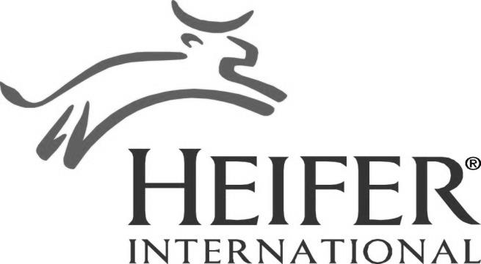
ALL PROCEEDS GO TO HEIFER INTERNATIONAL
Heifer International's mission is to work with communities to end hunger and poverty. By giving families a hand-up, not just a handout, we empower them to turn hunger and poverty into hope and prosperity. The chosen families get animals to sell their milk and meat; which in turn give another family in the town an animal a year later.

